**1 Towers Court Duckworth Street BLACKBURN BB2 2JQ**

**Tel: 01254 263350 Sales: Dennis 07715 127769 Toni 07872 414933 Admin: Mike 07792 842092**

**CONTRACT SOFA BED MATTRESS**

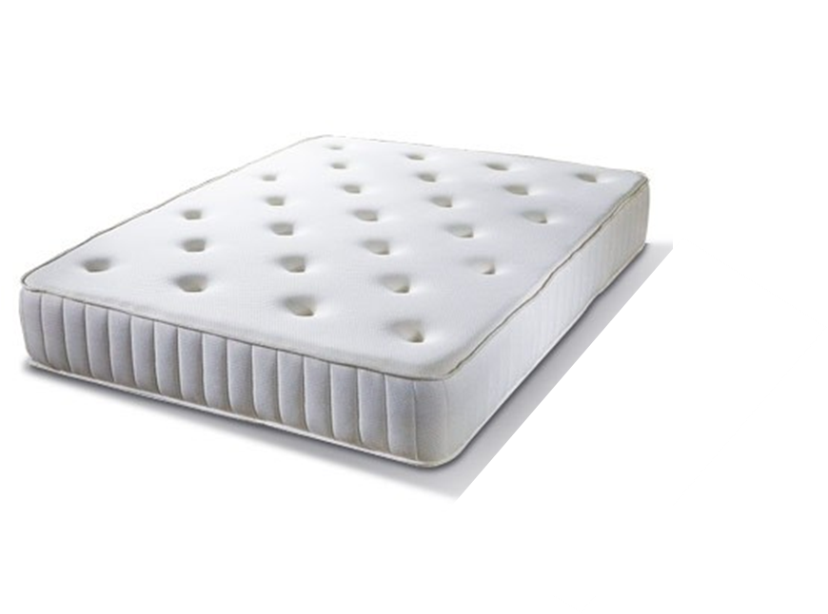

* ***13.5g Bonnell Spring***
* ***Luxury Ivory Viscon Fabric***
* ***Button Tufted***
* ***Medium to Firm Support***
* ***FR to Crib 5***
* ***Hand Made in UK***
* ***14cms Deep***
* ***2 Year Guarantee***

**The Mattress:**

The Contract Sofa Bed mattress is manufactured in the UK by a reputable National Bed Federation Member. It is constructed using a Bonnell sprung 13.5 gauge frame body which gives a medium firmness. In reality, sleepers are guaranteed a comfortable night's rest with **Bonnell Springs**. Generally, they are larger than those featured in pocket sprung mattresses, and the term 'open coil' refers to the fact that the **springs** are linked together in a wire frame for added support.

**Bonnell Sprung Example**

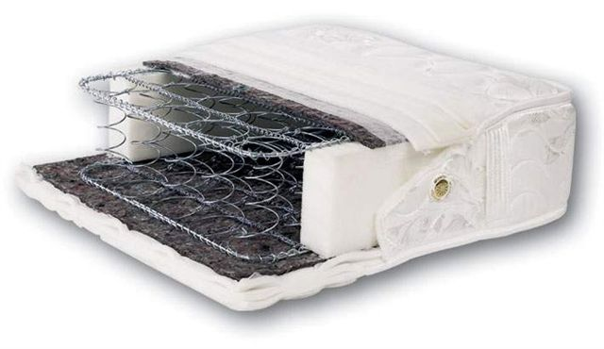

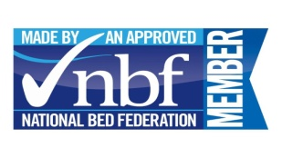

It is a full length mattress and is a generous 14 cms in depth. The mattress meets current FR regulations and is manufactured in **5 sizes** to fit the bed mechanisms. Our mattress comes with a full **2 Year Replacement Guarantee** against manufacturing defects. This mattress significantly contributes to the guest(s) having good nights sleep. Replacement mattresses are readily available.

**SOFA BED MODEL SIZE**

**80**

**100**

**120**

**140**

**160**

1995 mm

78

1480 mm

1280 mm

1080 mm

880 mm

1680 mm